**MySQL Queries**

1. **Use SELECT, WHERE, ORDER BY, GROUP BY**

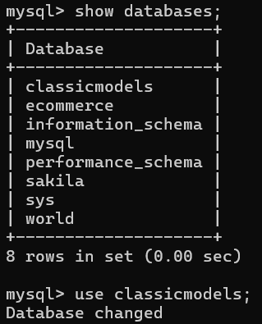

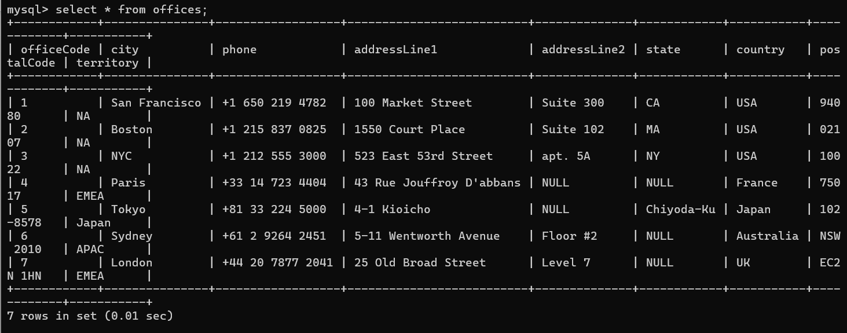

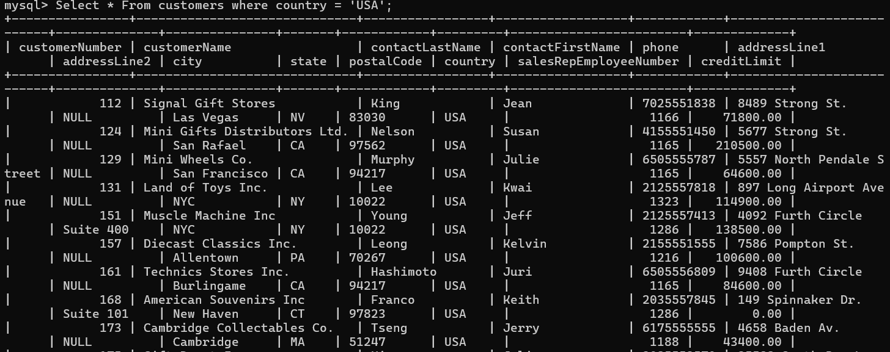

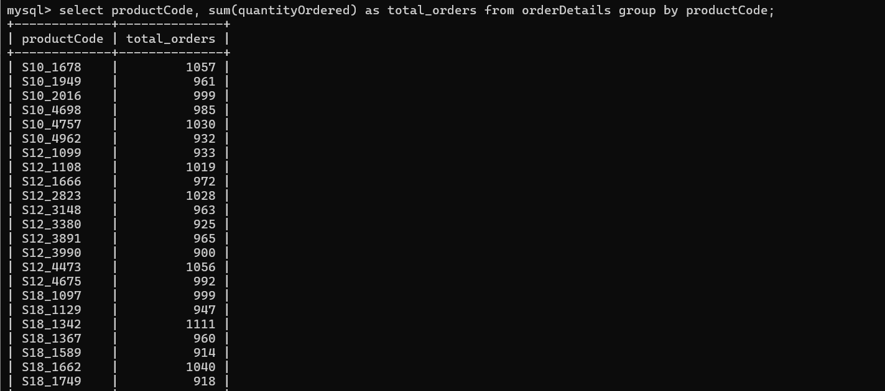

1. **Use JOINS (Inner, Left, Right)**

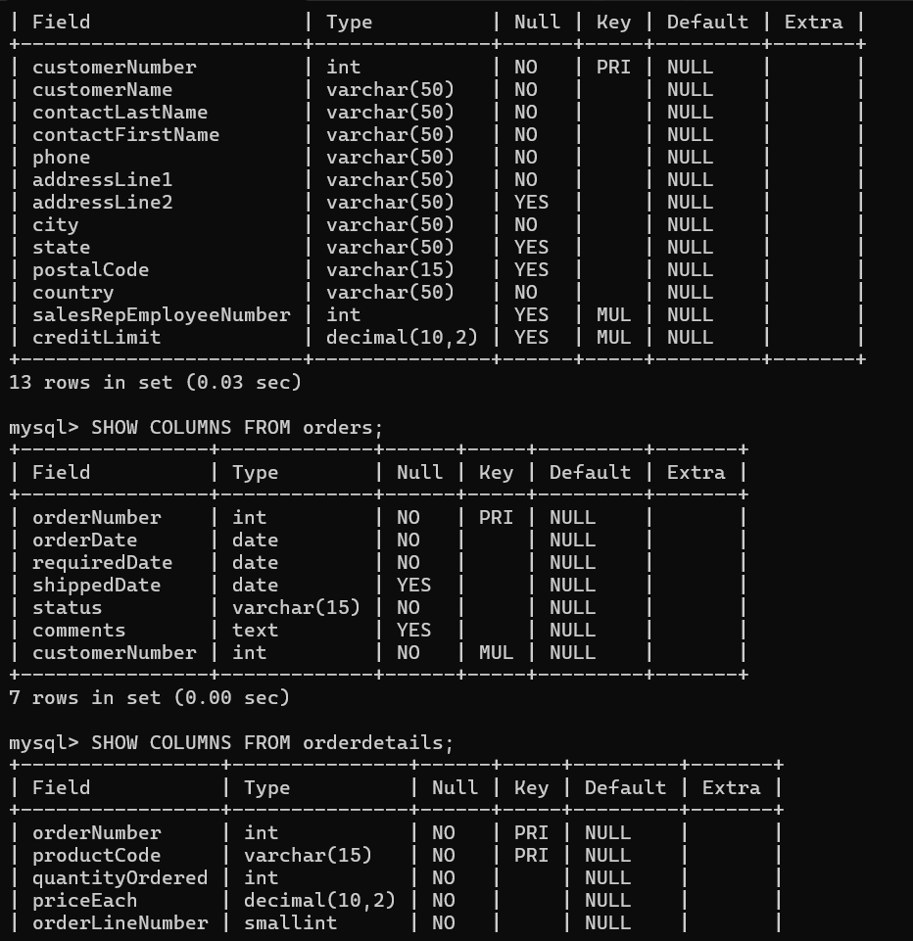

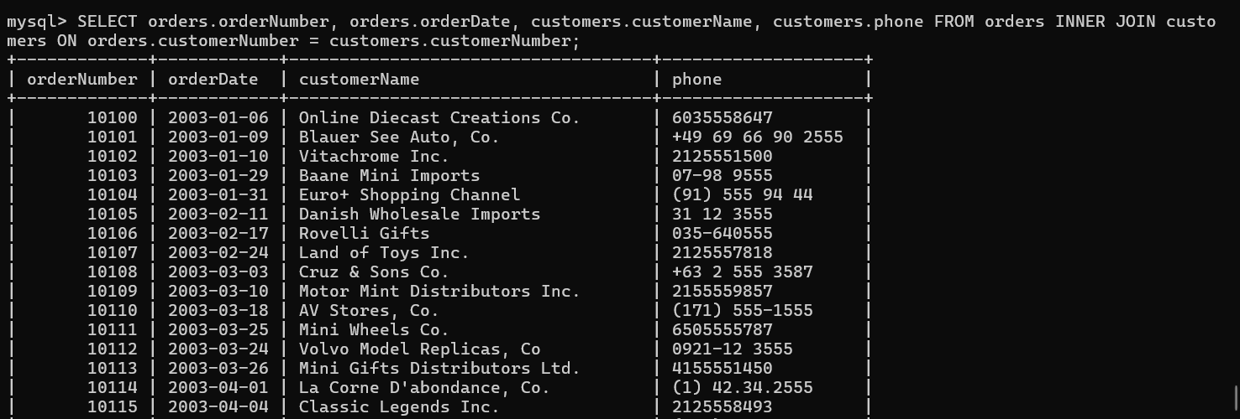

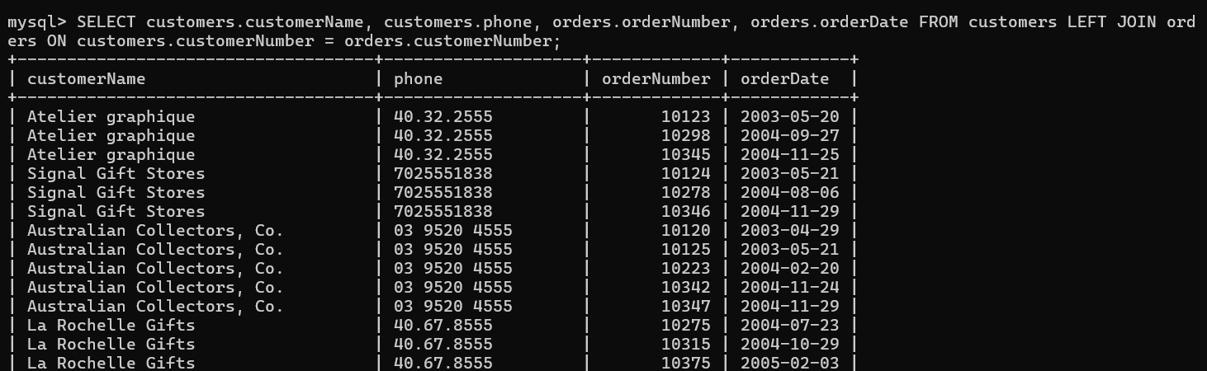

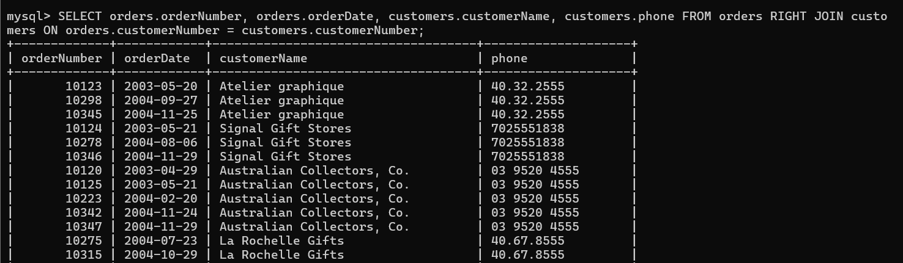

1. **Write Sub queries**

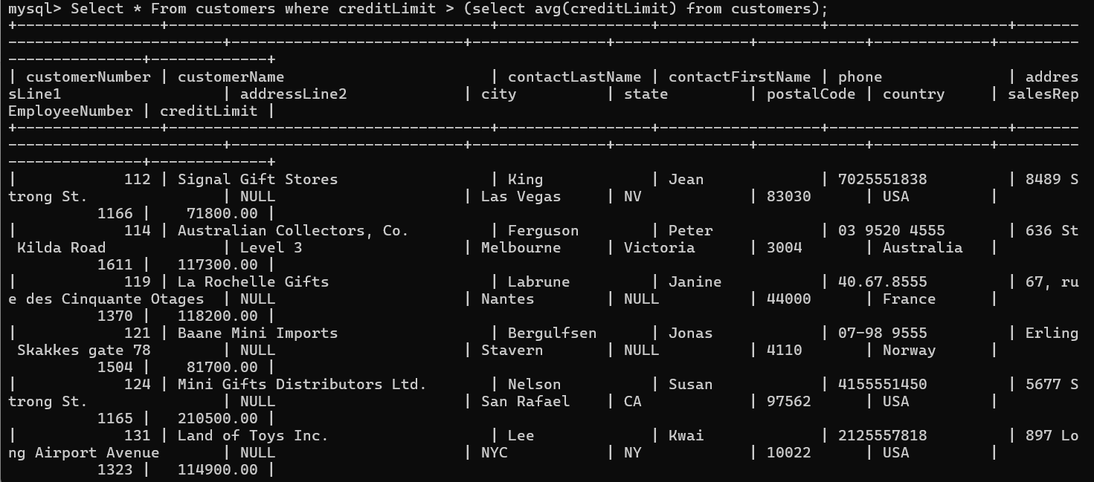

1. **Use Aggregate Functions (SUM, AVG)**

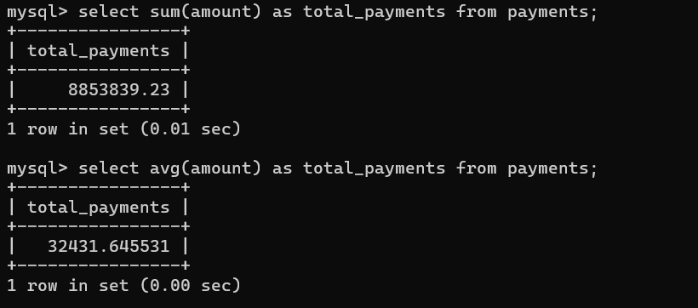

1. **Create views for analysis**

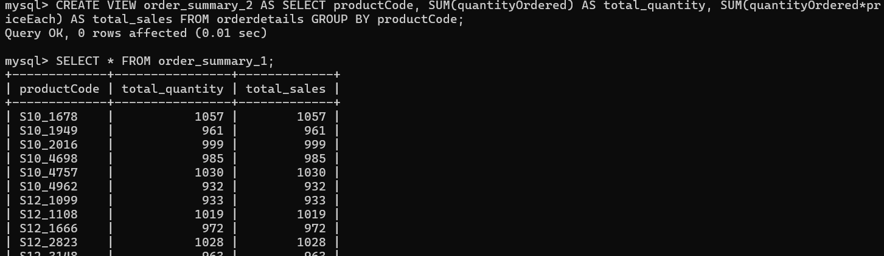

1. **Optimize queries with indexes**

